Wildlife Freedom Foundation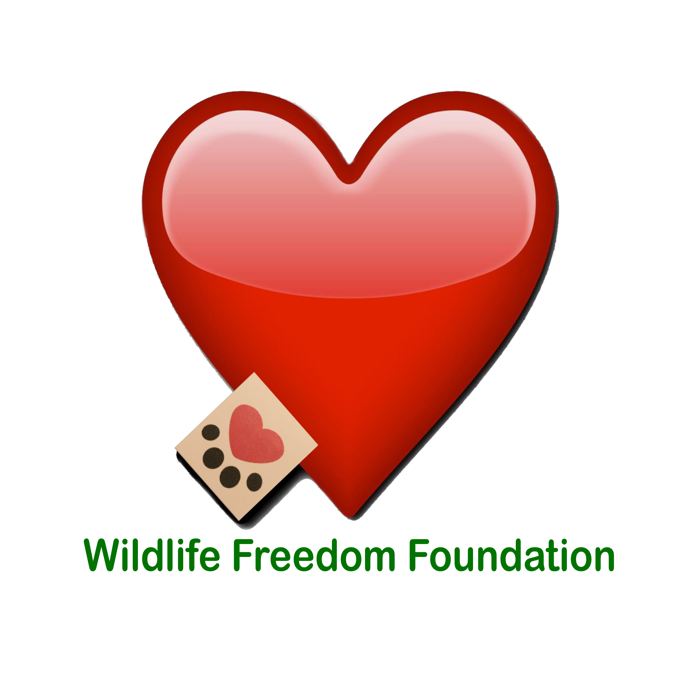

575 Main Street • Suite 1201 • New York, NY 10044 • wffny.info@gmail.com

New York State Registered Shelter/Rescue

Registration No.: RR350

The Wildlife Freedom Foundation, Inc. is a 501(c)(3) all volunteer organization committed to improving the lives of animals in distress. We facilitate Trap-Neuter-Return (TNR) programs, rescue and find homes for adoptable cats, perform community outreach and education, and engage in advocacy. We believe in working together to create a better life for the animals we rescue.

ADOPTION APPLICATION
Before placing a cat in your home, we would like to make a brief visit to your home to make sure that there are no cat hazards (loose window screens, spaces between kitchen appliances, poisonous house-plants, etc.). If your application will be approved, we will deliver your cat/kitten to its new home, and make a follow-up visit to be sure that you and your new cat/kitten are adjusting happily to life together.

CAT OR KITTEN YOU ARE INTERESTED IN

Cat/Kitten Name:

ABOUT YOU

First and Last Name: _____________________________________________

Occupation: _____________________________________________________

Home Address: __________________________________________________

City: __________State: _____________Zip: ___________
Home Phone: ____________________
Cell Phone: _________________
E-Mail Address (PRINT): __________________________________________________
Age of Applicant: 18 - 24____25-34____35-44____45+____

Do you live in a: House ___ Apartment _____ Do you: Own ___ Rent ____
If you rent, what is your Landlord’s name and phone number?

ABOUT YOUR HOUSEHOLD
Name of Spouse or Significant Other: ___________________________________________
Do you smoke?
Do you have children?
Who will be responsible for the cat’s care (the primary caretaker) feeding, cleaning the litter box, taking the cat to the vet etc.?
What is the age of this primary caretaker?
If you are away from home for an extended period, where will your cat stay?

Please supply two (2) personal references and tel. number (No family members).
We will call at least one.
- 1. ______________________________________________________

- 2. ______________________________________________________

ADOPTION INFORMATION

It is Wildlife Freedom Foundation policy to have a representative visiting the cat/s within the next three months:
Are you willing to have a WFF Representative visiting your home? Y -- N
Do your windows have screens? If not, will you agree to install screens at your windows?

Do you have any of the following? Patio____ Balcony____ Backyard_____
What is your past and/or current experience with cats?
1ST time owner_____ Have had cat/s as an adult _____ Had a cat as a child ____
Never had a pet______
Why are you adopting a cat?
Where will the cat/kitten sleep? Cat Bed_____ Bedroom ______ Other:
Will your new cat be an Indoor pet ______ Outdoor _______ Both ____
Do you have other cats? Or Dogs? Any other pets?
Please list all the pets you currently own:

Where does your pet come from?
Please list any pets you previously owned:
What happened to the pets you previously owned?
Have you ever surrendered an animal to a rescue/animal welfare organization?
If yes, what is the name of the organization? And if so, why have you surrendered the pet?

If deceased, what was the cause of death of your pet?
Do you plan to declaw your new cat/kitten? Yes___ No___ Unsure___
Depends on behavior_____
Name of current or previously used Veterinarian:
Vet’s Tel. Number:
Is there a cat behavior that would be unacceptable to you?
Please explain:

TELL US MORE ABOUT YOURSELF

Please list the names of all people living in the home and their relationship to you (Spouse/Partner/Children/Roommate)

Failure to fully disclose this information will result in immediate Adoption Denial.

Name: ____________________________________ Relationship:

Name: ____________________________________ Relationship:

Has anyone in the household have allergies or asthma?
If YES, have they consulted with their doctor about getting a pet?
If YES, are they taking medication?
Are you in the process of moving, or anticipate moving in the next few months?

Y--N

If you ever move, have you considered that another place may not allow pets?
What will you do if this happens?
Are there any other reasons you might give up a potential pet?

How would you describe your household? Active___ Noisy___ Quiet___ Average___
Where will you keep this cat/kitten? (Check ALL applicable options)
Free run of house ____ Crate in house___ Inside Cat___ Outside Cat___ Inside/Outside cat___ Basement _____Other (explain)
How many hours will he/she spend alone?
Where will he/she be kept when left alone?
Why do you want to adopt a cat/kitten: (Check ALL That apply)
House Pet___ Mouser___ Companionship____ Gift for friend or relative ___ Other (Please explain):

Will this cat ever be allowed outdoors? YES -- NO
If the cat would scratch your furniture, couch/chair/loveseat etc. will you consider declawing the cat/kitten?

APPLICANT'S AGREEMENT
- I agree that the animal is being adopted for myself and will not be sold, adopted, or given to any other party. If adopting a cat/kitten, I AGREE that I WILL NOT DECLAW THE CAT/KITTEN or ALLOW THE CAT/KITTEN OUTDOOR.
- The cat will live inside my home. I agree to care for the animal in a humane manner. This includes supplying love & care, adequate food, water, shelter, attention, and when and if necessary, veterinary care.
- I AGREE THAT IF AT ANY POINT I CANNOT KEEP THIS PET, I WILL RETURN IT TO THE WILDLIFE FREEDOM FOUNDATION WITHOUT REQUESTING A FEE. NO QUESTIONS ASKED.
- I understand and agree that the Wildlife Freedom Foundation makes no guarantees about the animal's temperament and it is not responsible for future damages or injuries caused by the pet.
- I give the Wildlife Freedom Foundation rescue group permission to call or visit my home at any reasonable time to assure that the cat/kitten is being properly treated and cared for. (Your initials here)
- I agree to keep the WFF informed of my current or new home address and phone number.
- By signing this form I acknowledge that all information on this application form are true and correct. Any falsification or misrepresentation may result in a denial of adoption and/or subsequent removal of cat or kitten from your home. Your initials here:______

I AGREE THAT ALL STATEMENTS I HAVE MADE ON THIS FORM ARE TRUE.
If it is found that any statements I have made on this form are not true the adopted cat/s can and will be confiscated immediately. (Your initials here)________

Adoption Process And Fees:

Adoption fees help offset some of the costs associated with providing for the cats and kittens in our care—this includes spay/neuter, housing, food/litter, medical care, enrichment, behavior modification, and more.
Should you decide to adopt a cat/kitten from us, we request a donation of $100 (Adult Cat) and $150 (Kitten) that will partially cover our expenses.

If you have questions or concerns, if unforeseen circumstances arise and you are unable to keep your adopted cat/kitten, we ask that he/she be returned to the Wildlife Freedom Foundation so that we will be able to find a new loving home for him/her.

The WILDLIFE FREEDOM FOUNDATION is in no way responsible for any damage, accident or injury resulting from the placement of a cat into my household.

Applicant Printed Name: _______________________________________

Applicant Signature: ___________________________________________

Date: ___________________

Thank you for completing this application!

*** WE RESERVE THE RIGHT TO DENY ANY ADOPTION ***

FOR WFF STAFF ONLY

WFF Adoption Counselor: (Print)_______________________________________

Adoption Counselor: (Signature)_______________________________________

WFF Adoption Approval:

WFF Adoption Denial:

Date: ________________________

