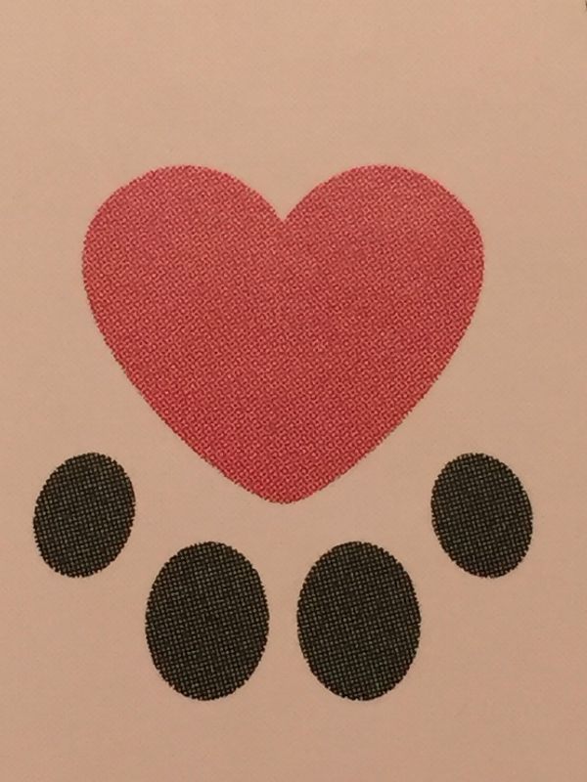
Wildlife Freedom Foundation, Inc.
575 Main Street #1201, New York, NY 10044 wildlifefreedomfoundation.org • wffny.info@gmail.com

The Wildlife Freedom Foundation expects its volunteers to maintain a high standard of conduct and work performance so that WFF maintains its good reputation with the community supporters and patrons.
Please complete this application if you are interested in volunteering for the Wildlife Freedom Foundation located in New York City. You must be 18 years of age to volunteer. All volunteers are required to attend a New Volunteer Orientation as a prerequisite before volunteering with us. We hope to meet you soon!

VOLUNTEER APPLICATION

Name:

Address:

City: State: Zip:

Primary phone:

E-mail:

Please describe any pets you have – names, ages, types (cat, dog, etc).

EMPLOYMENT:

Employment Status:

Occupation:

Employer:

May we contact your supervisor as a reference? YES – NO

MEDICAL:

REQUIRED:

I am current on my tetanus immunization: YES -- NO

Do you have any medical conditions or limitations that could hinder your participation in volunteer activities? YES – NO
If so, please describe.

AVAILABILITY:

Have you been a volunteer in the past? YES -- NO

Please list current or past volunteer experience below:

Is there anything likely to prevent you from keeping a six-month commitment to volunteer with WFF?

Please describe your experience with working/volunteer with animals in general, cats specifically – volunteer work, personal or professional experience and skills.

Please explain why you are interested in volunteering with the Wildlife Freedom Foundation:

We understand that your schedule might be different when you begin volunteering. We are trying to get an idea of your availability for program planning purposes.
Please indicate the days and times you are planning to volunteer:

Relevant skills and training (check all that apply):

Cats/Kittens – Foster--Socialization/Behavior
Feral Cat Trapping
Feeding and care
Fundraising/Event Planning
Special Event Support
Communications/Marketing
Media applications (website applications/programs and Graphics)
Carpentry/Construction/Maintenance

If there is an additional area you are interested in please describe:

Volunteer Waiver And Release Of Liability, Indemnification And Hold Harmless Agreement

This Waiver and Release Of Liability, Indemnification And Hold Harmless Agreement (“Agreement”) is between the volunteer and the Wildlife Freedom Foundation, Inc. (“WFF”) 575 Main St. #1201
NY, NY 10044 and its Directors, Officers, Members, Assigns and Successors.

- As a volunteer who is 18 years old or older, I hereby understand and agree to the following: I indemnify and hold the Wildlife Freedom Foundation, Inc. free and harmless from all liability arising out of any and all claims, demands, losses, damages, action, judgment, contracts, debts, injury to person or property of any and every kind and description which may occur to or be suffered by me, members of my household, or any third parties by reason of activities arising out of this agreement which has been or may have been caused partly by the negligence of the Wildlife Freedom Foundation. I agree to INDEMNIFY and HOLD HARMLESS the Wildlife Freedom Foundation for any costs or liabilities, which may incur as a result of my volunteering at or for the Wildlife Freedom Foundation.

- I acknowledge and agree to waive and release the Wildlife Freedom Foundation, Inc. from all responsibilities, manner of actions, causes of action claims and demands for or by reason of any illness, injury or incident, death, damage, loss or injury that may happen to me. This waiver does include myself, all of my family members and descendants forever from seeking any legal action whatsoever against Wildlife Freedom Foundation, Inc. or its representatives, sponsors and volunteers.

I acknowledge and agree that I have read carefully this Agreement, that I fully understand the Agreement, and that I freely and voluntarily execute the same.
I understand that I may seek independent advice prior to signing this Agreement. The terms of this agreement are contractual and NOT mere recitals. This Agreement will be construed in accordance with and governed by the laws of New York State.

Signature: Date:

Emergency Contact Phone:

** Due to the nature of WFF’s services, we reserve the exclusive right to select or not to select potential volunteers at any point before services are provided or after placement in the program.

Thank you for your time and interest. We deeply and sincerely appreciate what you do for us and for the cats and kittens, and we pledge to do our best to make your volunteer experience with the Wildlife Freedom Foundation worthwhile and rewarding.

