Wildlife Freedom Foundation 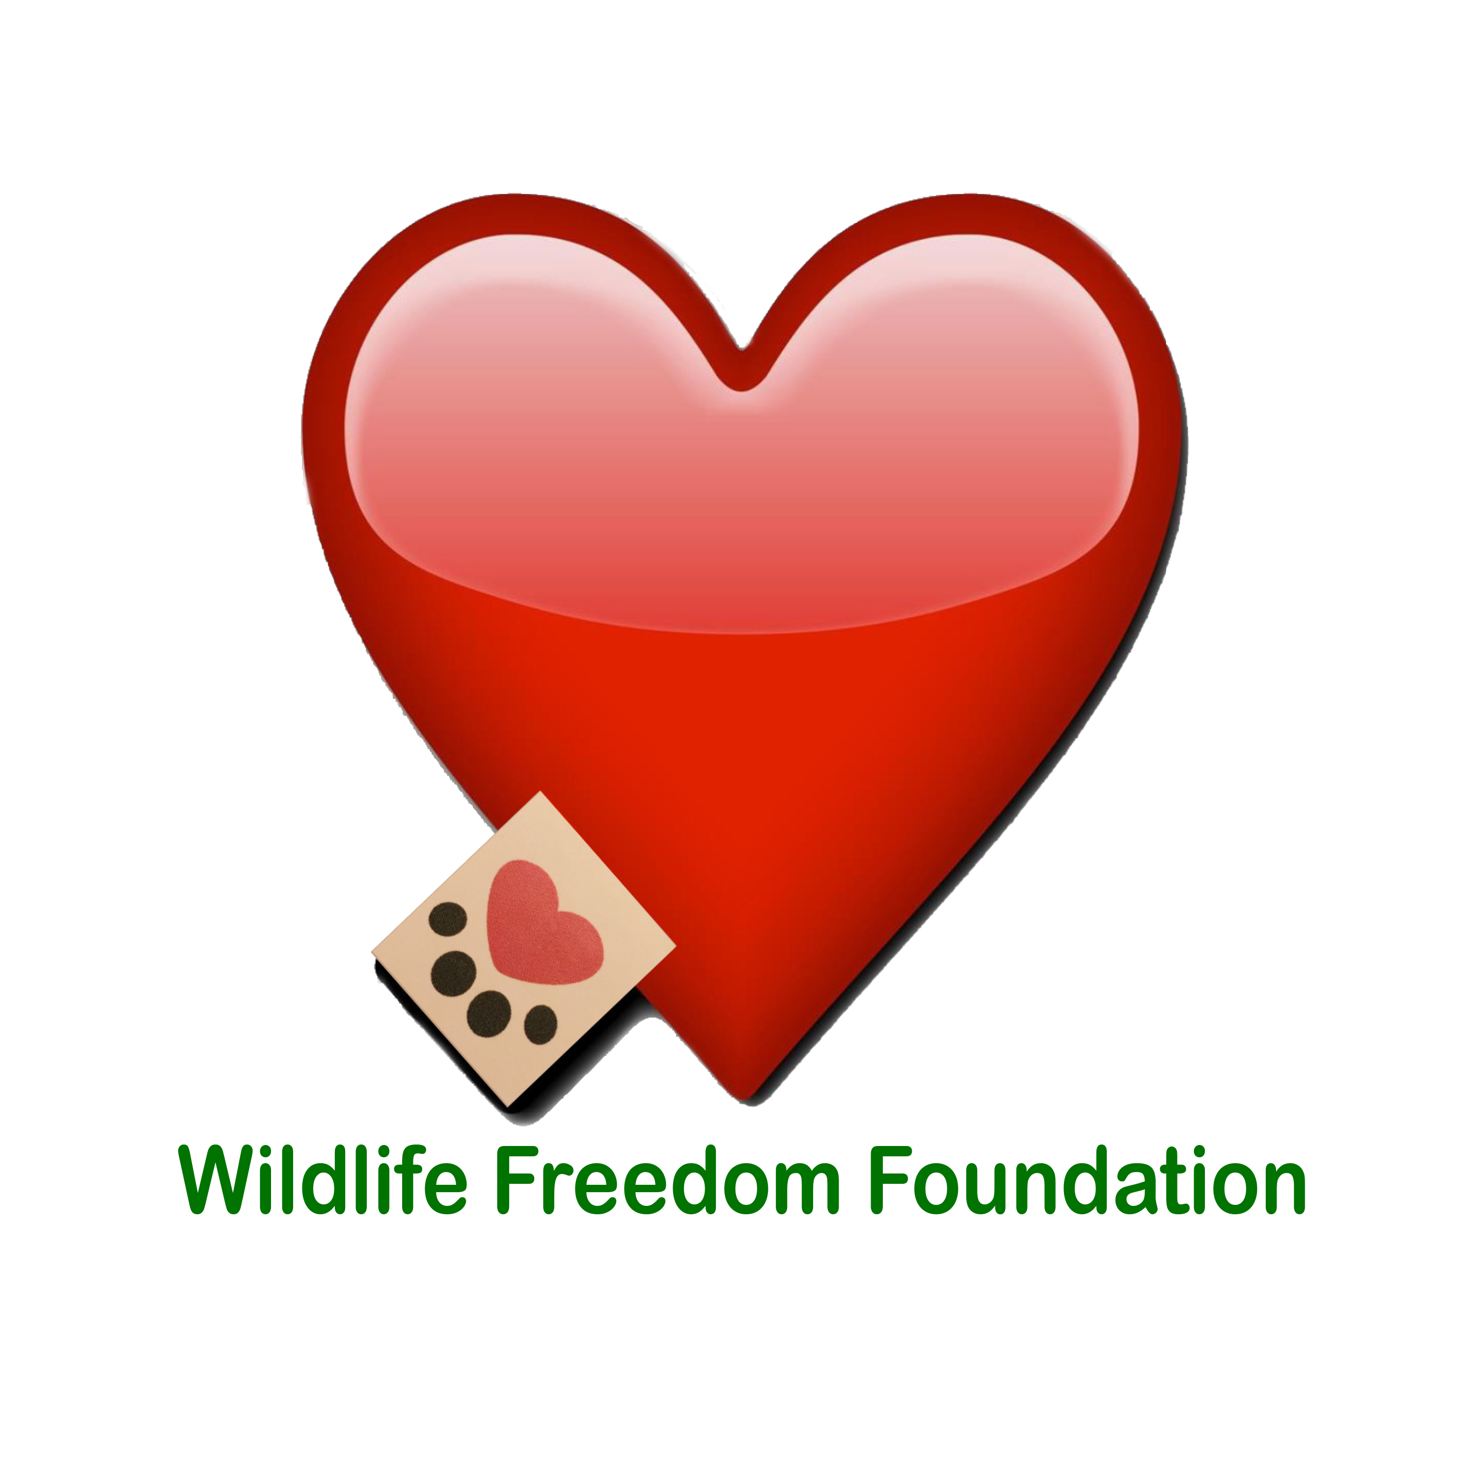
575 Main Street • Suite 1201 • New York, NY 10044 •
wildlifefreedomfoundation.org • wffny.info@gmail.com

The Wildlife Freedom Foundation, Inc. is a 501(c)(3) all volunteer organization committed to improving the lives of animals in distress. Working with our communities, we facilitate Trap-Neuter-Return (TNR) programs, find homes for adoptable cats, perform community outreach and education, and engage in advocacy. We believe in working together to create a better life for the animals.
ADOPTION APPLICATION
Before placing a cat in your home, we would like to make a brief visit to make sure that there are no cat hazards (loose window screens, spaces between kitchen appliances, poisonous house-plants, etc.). We will deliver your cat/s/kitten/s to its new home, and make a follow-up visit to be sure that you and your new cat/s are adjusting happily to life together.

Cat/Kitten Name:
Please fill out the following application in its entirety!

First and Last Name: _______________________________________________

Address: __________________________________________________________
City: __________State: _____________Zip: ___________
County: _______________ Home Phone: ____________________
Cell Phone: _________________
E-Mail Address (PRINT): __________________________________________________
Driver’s License/State ID number: _________________________________________
Do you live in a: House _______Apartment ________
Do you: Own __________ Rent _________
If you rent, what is your Landlord’s name and phone?
Are you 18 years of age or older? _______
Please supply two (2) personal references (name and phone number). We will call at least one.

- 1. ______________________________________________________

- 2. ______________________________________________________

ADOPTION INFORMATION

It is Wildlife Freedom Foundation policy to have a representative visiting the cat/s within the next three months:
Are you willing to have a WFF Representative visiting your home?
Do your windows have screens?
If not, will you agree to install screens at your windows?
What is your past and/or current experience with cats?
1ST time owner______ Have had cats as an adult _____ Had a cat as a child _____Have had more than 3 cats as an adult ______
Why are you adopting a cat/kitten? __________________________
Where will the cat/kitten sleep at night? Cat Bed_____ Bedroom ______ Other: _________
How many hours of the day will your cat/s be left alone? __________
Will your new cat/s be an Indoor pet? ______ Outdoor? _______ Both?
Do you have other cats? ______ Any Dogs? __________
Please list the number of pets you currently own ________
Where does he/she/they come from?
Please list any pets you previously owned:
What happened to the pets you previously owned?
Have you ever given/sold an animal to a family member or others?
Have you ever surrendered an animal to a rescue or animal welfare organization?
If yes, what is/are the organization/s? _________________________________
And if so, why? _________________________________
If deceased, what was the cause of death?
Do you plan to declaw your new cat/s?
If you own or previously owned a cat is/was he/she declawed?
TELL US MORE ABOUT YOURSELF

Please list the names of all people living in the home and their relationship to you (Spouse/Partner/Roommate/Children)?

Failure to fully disclose this information will result in immediate Adoption Denial.

Name and Age: ____________________________________ Relationship: _____________

Name and Age: ____________________________________ Relationship: ______________

Does anyone in the household have allergies to any kind of animals?
If YES, have they consulted with their doctor about getting an animal?
If YES, are they taking medication? _________________
Are you in the process of moving, or anticipate moving in the next few months? Yes __________ No___________
If you ever move, have you considered that another place may not allow pets?
What will you do if this happens?
Are there any other reasons you might give up a potential pet/s?

How would you describe your household? Active____ Noisy____ Quiet____ Average____
Where will you keep this cat/kitten? (Check ALL that apply)
Free run of house ______ Crate in house___ Inside Cat___ Outside Cat Inside/Outside cat Basement _____Other (explain)____________________
How many hours will he/she/they spend alone?
Where will he/she/they be kept when left alone?
Why do you want to adopt a cat: (Check ALL That apply)
House Pet____ Mouser____ Companionship______ Travel Companion_____Gift for friend or relative ______ Other (Please explain)_________________________
Will this cat ever be allowed outdoors? YES_______ NO________
If the cat would scratch your couch/chair/loveseat etc. Will you consider declawing the cat/s kitten/s?

ADOPTER'S AGREEMENT
- I agree that the animal is being adopted for myself and will not be sold, adopted, or given to another party. (If adopting a cat/kitten) I agree that I WILL NOT DECLAW THE CAT/KITTEN OR ALLOW THE CAT/S KITTEN/S OUTDOORS.
- The cat/s will live inside my home. I agree to care for the animal in a humane manner. This includes supplying love, adequate food, water, shelter, attention, and when/if necessary, medical care.
- I AGREE THAT IF AT ANY POINT I CANNOT KEEP THE ANIMAL, I WILL RETURN HIM/HER/THEM TO THE WILDLIFE FREEDOM FOUNDATION, INC. WITHOUT REQUESTING A FEE. NO QUESTIONS ASKED.
- I understand and agree that the current rescue group makes no guarantees about the animal's temperament and is not responsible for future damages or injuries caused by the animal/s.
- I give the Wildlife Freedom Foundation rescue group permission to call or visit my home at any reasonable time to assure that the cat/s kitten/s is/are being properly treated and cared for. (Your initials here)
- I agree to keep the WFF informed of my current or new home address and phone number.
- The answers to the above questions are true to the best of my knowledge. By signing this form I/we acknowledge that all information on this application form are true and correct. Any falsification or misrepresentation may result in a denial of adoption and/or subsequent removal of cat/s or kitten/s from your home. Your initials here________________
I AGREE THAT ALL STATEMENTS I HAVE MADE ON THIS FORM ARE TRUE.
IF IT IS FOUND THAT ANY STATEMENTS I HAVE MADE ON THIS FORM ARE NOT TRUE THE ADOPTED ANIMAL/S CAN AND WILL BE CONFISCATED IMMEDIATELY. (Your initials here)_______________________
Our Adoption Procedure: We will review your application and then get back in touch to schedule times for you to meet potential pets if we have an animal that suits what you are looking for. If you do decide to adopt a cat/kitten from us, we request a $100 (for adult cats) or $150 (for kittens) donation to partially cover our expenses.

If you have questions or concerns, if unforeseen circumstances arise and you are unable to keep your adopted cat, we ask that he/she/they be returned to us and we will find him/her/them a new home.

Adopter’s Printed Name: ________________________________________

Signature: ______________________________________________________

Date: ___________________

Thank you for answering all our questions!

*** WFF RESERVES THE RIGHT TO DENY ANY ADOPTION. ***
FOR WFF STAFF ONLY

WFF Adoption Counselor: (Print)____________________________________________

(Signature)________________________________________

WFF Adoption Approval

WFF Adoption Denial

Date: ________________________

